Screenshot of home page

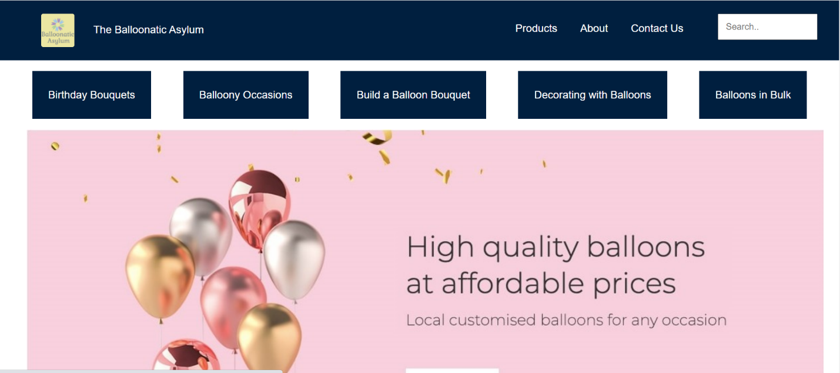

Screenshot of about page

